Survivor Toolkit Quiz and Answers

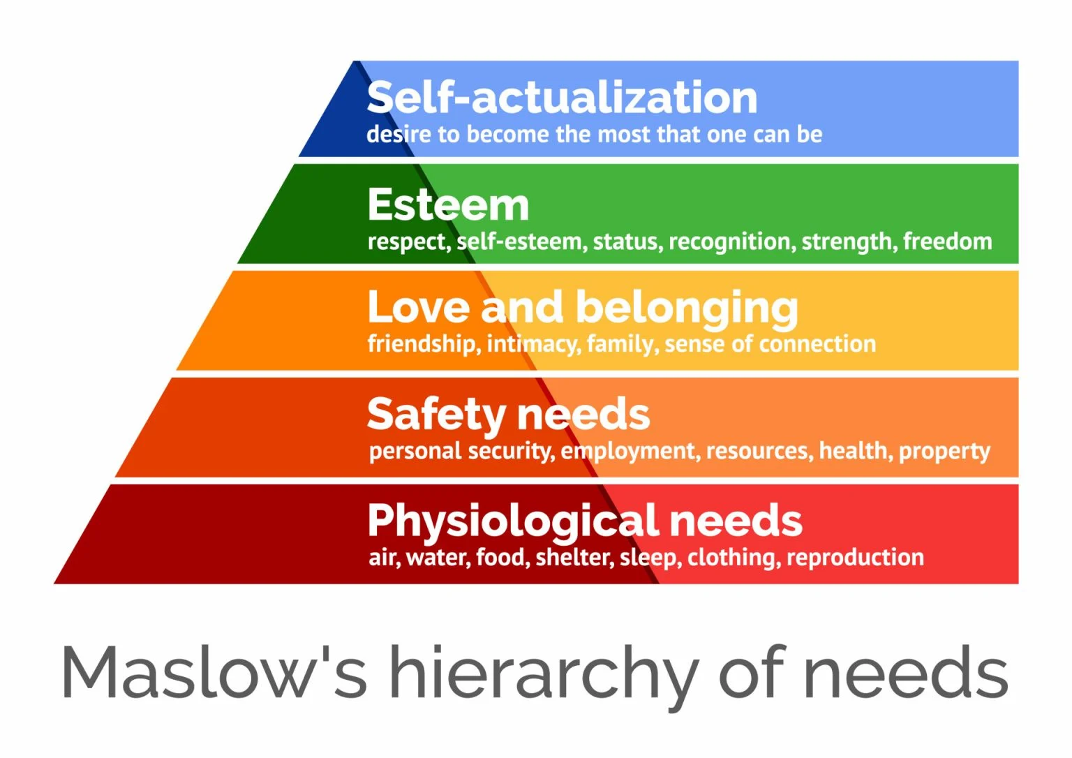

Quiz Questions 1-25 (breakdown of needs)

- Do you feel physically safe with the people around you/people you are staying with? (ex. Has anyone threatened you, do they have access to a deadly weapon? Are you fearful for your bodily integrity) Y/N
- Do you know where you are presently? (city/state) Y/N
- Are you able to leave your current location? (could you walk out the front door by yourself whenever you want?) Y/N
- Do you have access to a car or public transportation? Y/N
- Have you eaten in the last 24 hours? Y/N
- Do you have control over the food you eat? (do you have access to food options? can you decline food that is offered to you? are you forced to eat food that you don’t want?) Y/N
- Do you have a safe place to stay for the next 2 weeks or so? Y/N
- Do you have any life-threatening illnesses or conditions? Y/N
- Do you have any substance addictions? Y/N
- Have you attempted or seriously considered suicidal action in the last 72 hours? Y/N
- Do you feel emotionally safe? (Do you feel like you have control over your thoughts? Do you feel safe expressing your emotions?) Y/N
- Do you have any children or relatives under the age of 18 who consider you as a parent? Y/N
- (If yes to #12) Do you know where those children are? Y/N
- Do you have a safe person you can contact? Y/N
- Do you have control over your money? Y/N
- Do you feel empowered in your work? (ex. Could you seek different work if you wanted to, do you feel supported in your work?, are you threatened or harassed if you don’t make a certain quota) Y/N
- Have you graduated High School or received your G.E.D? Y/N
- Do you have a form of government-issued ID? (driver’s license? Passport?) Y/N
- Do you have access to your birth certificate and or your social security card? Y/N
- Are you actively searching for employment? Y/N
- Do you need or would you be interested in consulting a lawyer? Y/N
- If you are not in contact with your family, do you want to be reconnected with them? Y/N
- Are you maintaining meaningful friendships? Y/N
- Are you involved with a local church or community group? Y/N
- Do you have hopes and dreams for the future? Y/N

Quiz Answers and Categories (1-16 Physiological and Safety Needs)

- If you do not feel physically safe and you are not able to leave your location, your best option is to call 911. It is not an easy choice to make. Calling 911 will get local authorities involved in your situation, but if it is between you calling authorities and your life being on the line we strongly urge you to call 911.

- You can try the pizza ordering method if you are worried your significant other or trafficker will react violently to you calling 911 for help. When the operator picks up: 911 what is your emergency?

You: I need to place an immediate order for pizza delivery. It is very urgent. My (boyfriend, husband, friend, etc.) and I are really hungry. The address is (state address if you can otherwise 911 operators should be able to ping your call)

- In some areas it is possible to text 911 but this is limited to certain areas and it is almost always better to call.

- Knowing where you are will help emergency services to get to you faster. If you are not in an immediate emergency, but you do need resources or want to know where to go for help, knowing where you are is the next step.

- If you trust the people around you, ask them where you are
- Look for mail or packages that have the address sticker on them
- If you have access to an internet connected device, search “Where am I located” for a city/state listing

- If you are not free to leave whenever you like, it is likely that you are being falsely imprisoned and you should seek out help from law enforcement.

- If you don’t have access to a car, but you do know there is a reliable public transit system in your area, here are some resources in the Chippewa Valley that can help you get to your next destination.

- Western Dairyland provides free bus tokens. Eau Claire office number is 715-836-7511
- Wisconsin Department of Health Services Veyo https://www.dhs.wisconsin.gov/nemt/index.htm

- Salvation Army provides transportation and bus tokens as well as other resources. Salvation Army U.S.A. Central Territory (1-800-725-2769 or online at centralusa.salvationarmy.org)

- If you haven’t eaten in the last 24 hours or you don’t know where your next meal is coming from, there are some local resources that can help you.
- You can find your local foodbank through Feed My People at this link https://www.feedingamerica.org/find-your-local-foodbank
- You can stop by the Community Table in Eau Claire at 320 Putnam St. Eau Claire WI 54703 for dinner any day of the year https://thecommunitytable.org/

- Although you may have access to food, not being in control of what you eat or when you eat it could be a sign of abusive or controlling behavior by someone around you.
If you think you might be in a domestic abuse situation please call or text the domestic abuse hotline.
- Call: 800-799-7233
- Text: START to 88788

- Having a safe place to live is essential to thriving in the future. Although housing options are limited in the Eau Claire area there are still places you can go.
- Hope Gospel Mission offers a 30-day short-term program and 1.5 year long-term program for males and females. You can begin the application process at this link https://www.hopegospelmission.org/fresh-start/
- If you are leaving an abusive relationship and need a safe place to stay you can contact Bolton Refuge House https://www.boltonrefuge.org/ or call them at the following numbers
Eau Claire County: 715-834-9578
Jackson County: 715-333-2350
Buffalo County: 715-834-9634

- The Center for Independent Living is part of a network of Wisconsin Independent Living Centers that are non-residential, private, non-profit, consumer-controlled, community-based organizations providing services and advocacy by and for persons with all types of disabilities. Their goal is to assist individuals with disabilities to achieve their maximum potential within their families and communities. Contact them here.
- Retreat Center: Angel’s Healing & Retreat Center - Contact (608) 432-5818 or email Angel@AngelWingsHealingCenter.org for more information about resources

- Getting proper medical treatment is essential to being the best you can be so that you can thrive.
- You can contact local hospitals through:
https://www.mayoclinichealthsystem.org/locations/eau-claire/ or call them at (715-838-5222)
And
- https://www.prevea.com/ (715-839-5175)

- Admitting you struggle with addiction is a powerful step forward on the journey to recovery. There are additional resources in the area to assist you as you move forward in battling your addiction.
- Transitional Housing Programs are available through DHS and there is a free number you can call 24/7 for addiction assistance. Call (1-800-304-2219) or visit https://www.addicted.org/transitional-housing-wisconsin.html
- Lutheran Social Services Drug Rehab Center https://rehabnow.org/center/lss-lutheran-social-services-positive-avenues-eau-claire-wi/ or call (888-674-0062)
- Family Therapy Associates offers appointments in person, over the phone, or over video and is covered by most insurances. https://www.ftacounseling.com/ or call (715-246-4840)

- If you struggle with depression, suicidal thoughts, or actions you are not alone. Your life has meaning. You did not survive all you have survived for it to end now. There are better days ahead.
- Call 988 or text for a 24/7 suicide prevention hotline
- Crisis Intervention by Eau Claire Department of Human Services (888-552-6642), available 24/7
- Great Rivers- call 211 or (800) 362-8255 for addiction or crisis help

11-12. If you have children under the age of 18 and don’t know where they are, contacting social services would be the next best step. Also, if a child has experienced trauma and is in need of services, contact the Child Advocacy Center - 715-835-5915
- Contact the Eau Claire County Government Center at 721 Oxford Ave, Eau Claire, WI 54703 or call (715-839-2300)
- Contact Apple Pregnancy Center: For pregnancy support, post-abortion counseling, or parenting classes. Hotline: 715-834-7734 - Email: needs@applepcc.org
- Contact Chippewa County Department of Human Services at 711 N Bridge St #305, Chippewa Falls, WI 54729 or call (715-726-7788)

16. If you do not feel empowered in the work that you do and don’t feel like you could leave that work without suffering serious physical harm, threats of physical harm to you or loved ones, threats of deportation, imprisonment, or other legally charged threats you might be a victim of labor trafficking. There are resources to help you, some of which have previously been listed.

- Call or text the U.S. National Trafficking Hotline: Phone 1(888) 373-7888 or text “BeFree” 233733
- Call 988 Suicide or Crisis Hotline

17. Having your High School Diploma or GED is essential in moving forward to better job opportunities and further education if desired. Individuals who attain their HS Diploma or GED are less likely to fall below the poverty line than those who don’t.

- https://www.cvtc.edu/academics/high-school-diplomas#ged-hsed (CVTC/Eau Claire & Chippewa)
- https://www.northwoodtech.edu/academic-programs/academic-support-services/ged-and-hsed (Northwood Tech Rice Lake, Barron, Superior, and New Richmond)
- https://www.ntc.edu/academics-training/ged-hsed (Taylor County)

Love and Belonging: (Questions 18-24)

18-19. Having access to a government-issued form of ID is necessary for various reasons including: interactions with law enforcement, applying for a job, opening a bank account, purchasing a gun or any controlled substance, even something as basic as certain over-the-counter medications. If you wish to get access to form of government issued ID here are some resources for you:

- Contact Vital Records Customer Service
Phone: 608-266-1373
Email: DHSVitalRecords@dhs.wisconsin.gov

- Tony Mau from Windows to Work (Dept. of Corrections) 715-619-1018

- For assistance with this process, contact Family Support Center by calling 715-723-1138 or email familysupport@fsccf.org
- website where you can report your card stolen or apply for a new one.
- Have a disability and need help applying? The Aging and Disability Resource Center of Eau Claire County- ADRC of Eau Claire County Phone: 715-839-4735 Toll Free: 888-338-4636
Email: adrc@co.eau-claire.wi.us

20. The search for a job after being a victim of human trafficking can be full of obstacles, but there are resources out there to assist you in your search.

- Aurora Vocational Services https://www.auroraservices.com/vocational
Available (Mon-Thur 8am-4pm) (715-514-2477)
- Eau Claire County Job Center by Workforce Resource Central Office https://www.workforceresource.org/home.php Available (Mon-Fri 8am-4:30pm) (715-858-9675)
- Supported Employment by Reach https://www.reach-inc.org/employment Available (Mon-Fri 8am-4pm) (715-833-7755)
- https://blackwell.jobcorps.gov/ The Blackwell Job Corps especially assists young adults ages 16-24 and gives priority to victims of trafficking in job placement.

21. As a victim of human trafficking, you are the victim of a crime. Additionally, you may have questions regarding taxes, custody of your children, protecting yourself from your trafficker or abuser, how to access your legal record or if it is possible to clear it, or what to do if you were a victim of IBA (image-based abuse). These types of legal questions may be answered by a lawyer. If you have questions like these or would like to consult a lawyer for another matter there are resources available to you.

- Assistance with Judicare applications, restraining orders, divorce paperwork, and support during criminal, family, and civil court hearings. Does not provide legal advice.
Call 715-723-1138 or email familysupport@fsccf.org

- Judicare Legal Aid provides free civil legal services to low-income persons living in Northern Wisconsin and Native Americans statewide.
https://www.judicare.org/

- https://www.justice.gov/humantrafficking/resources

- https://www.lsc.gov/grants/our-grantees - To find free legal aid in your area

- Legal Services for Image-Based Abuse (removing images online from when you were a minor)
https://takeitdown.ncmec.org/

22. If you are interested in locating and or reconnecting with your family, you are the best resource, but there are other options too.

- Search through social media accounts like Facebook and Instagram
- Search through government agencies like the Department of Human Services

23. Building meaningful friendships helps individuals to thrive and be the best they can be. Many people find friendships through community groups or common interests. As a survivor, you have seen some of the worst of humanity and its important to ask yourself questions when considering if a person or a group of people would lead to healthy meaningful relationships,and not into a relationship that leads to manipulation or further abuse. Here are some questions to consider when looking for friendships:

- Do you trust this person? If you tell them something deep and personal about your life, does it stay between the two of you or do other people hear about it too?
- Do you like who you are when you are with this person? Do they bring out the best in you? Do they encourage life-giving habits? Do they push you to be the best you can be?
- How does this friend react when you tell them good news? Almost anyone can show sympathy if you tell them bad news, but a true friend can be happy with you when you succeed without being jealous or petty.
- Do you like where your friend is at in their life right now? Are you proud of them or impressed by them? People and relationships have the power to pull you up or push you down. The saying “Show me your friends and I will show you your future” has wisdom to it. Choose people that are pursuing dreams and passions better than their current situation, and use that same energy and momentum to push forward in your dreams. If your “friends” always are stuck or can never get anything going in their lives, it may impact you and your momentum sooner than later.

24. You don’t have to be religious to go to a church service. Finding community or common interests with others around something bigger than yourself can give your life new meaning and perspective. There are some really great churches in the area, but if you are not ready for that yet, you can try finding hobby groups or volunteering in your community.

Local Churches:

- Harvestime Church Eau Claire https://htcfamily.org/ (southside)
- ValleyBrook Church Eau Claire https://valleybrookchurch.org/ (downtown)
- Bethesda Lutheran Church https://c3ec.org/
- Get Jesus Fit https://www.facebook.com/jesusfitfaith

Looking for Faith but maybe not a Church?
- https://harmonygrillo.com/
- Celebrate Recovery is an American Christian twelve-step program designed to facilitate recovery from a wide variety of troubling behavior patterns. Find one that meets near you at: https://www.celebraterecovery.com/

Community Groups:
- Search Common Interests in Facebook Groups
- Find a recreation group from Bicycling to Curling to Figure Skating with the Volume One listing https://volumeone.org/sites/recreation/listings/categories/200067-recreation-organizations

Volunteering:
- https://www.volunteermatch.org/search/orgs.jsp?r=20.0&l=Eau+Claire…
- https://volumeone.org/listings/categories/200169-volunteer-opportunities-charities

Esteem and Self-Actualization:

25. What you look at determines where you are going. If you have hopes and goals for your future you are more likely to achieve that future for yourself. What goals do you have for yourself? Achieving financial freedom? Becoming mentally and physically stronger? Learning a new language? Owning a business? Traveling the world? What is the mark that you want to leave on the world? These are good questions to consider and there are resources available to make it possible.

- Financial Freedom for trafficking survivors with Polaris Project: https://polarisproject.org/the-resilience-fund/
- Freeform Savings Matching Program: https://www.freefrom.org/
- Free cellphone and laptop through Q-Link: https://qlinkwireless.com/
- Tattoo Removal for victims of trafficking: https://restorativeink.com/
- The Largest Online School for Victims of Human Trafficking: https://elevate-academy.org/
- Learn how to defend yourself through martial arts https://www.gracieuniversity.com/ Gracie Jiu-Jitsu specializes in women’s self-defense and in helping a smaller person leverage their strength.

